ECE 232

Lab
Transformers

Objective:
- To learn how real world transformers operate under ideal conditions.
- To learn what happens to the output voltage when the transformer is loaded.

Preliminary Work:

- Consider the ideal transformer shown in Figure 1.

Figure 1

  - Show the relation between $V_{1, }{ V}_{2, }{ I}_{1, } and I_{2, }$

  - If V$=220 V AC,{ V}_{2}=6 V and Power=100 VA$ , calculate$V_{1} and n.$
  - If ${ V}_{2}=12 V .$Calculate $V_{1 }and n$.

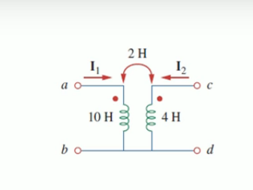

Figure 2

a)Determine the T equiavalent circuit of the linear transformer in Fig 2
3) Determine the Π equivalent circuit of an linear transformer shown in Figure 3.

Figure 3

EXPERIMENTAL WORK

- Set up the circuit of Figure 2. Adjust the sine wave output of the signal generator so that V_{in}(t) is a sine wave with 50Hz frequency.
2)Determine the complex power for the primary winding.

