ECE 232 LAB 11
CIRCUIT STATE-SPACE MODELING
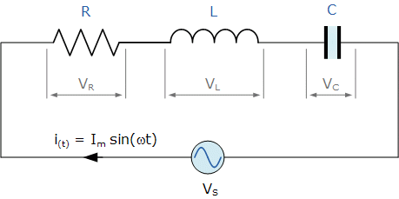

Find a state space representation for the RLC circuit shown in Fig and assuming the output to be $V_{out}$ and the state vectors
$X_{1}(t)$=voltage across the capacitor ;
$X_{2}(t)$=inductor current ;
---------------------------------------------------------------------------------------------------------------------------------------------------------------------------------------------------------------------------------------------------------------------------------------------------------------------------------------------------------------------------------------------------------------------------------------------------------------------------------------------------------------------------------------------------------------------------------------------------------------------------------------------------------------------------------------------------------------------------------------------------------------------------------------------------------------------------------------------------------------------------------------------------------------------------------------------------------------------------------------------------------------------------------------------------------------------------------------------------------------------------------------------------------------------------------------------------------------------------------------------------------------------------------------------------------------------------------------------------------------------------------------------------------------------------------------------------------------------------------------------------------------------------------------------------------------------------------------------------------------------------------------------------------------------------------------------------------------------------------------------------------------------------------------------------------------------------------------------------------------------------------------------------------------------------------------------------------------------------------------------------------------------------------------------------------------------------------------------------------------------------------------------------------------------------------------------------------------------------------------------------------------------------------------------------------------------------------------------------------------------------------------------------------------------------------

EXPERIMENTAL PART:
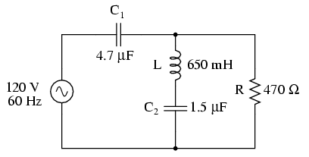

Plot the $V_{out }$vs $V_{in}$ and show the Voltages,Peak to Peak ,Time/Div ,Volt/Div, probe vs..
Voltages:____
P-p=_____
Time/Div=____
Volt/Div=____

