LAB 6 20-21.03.2019
ECE 232 –ADVANCED ELECTRICAL CIRCUIT ANALYSIS +LAB
FREQUENCY RESPONSE (PHASE,MAGNITUDE CHARACTERISTICS)

Q-1)
a-) Determine the differential equation for the given circuit in below .

----------------------------------------------------------------------------------------------------------------------------------------------------------------------------------------------------------------------------------------------------------------------------------------------------------------------------------------------------------------------------------------------------------------------------------------------------------------------------------------------------------------------------------------------------------------------------------------------------------------------------------------------------------------------------------------------------------------------------------------------------------------------------------------------------------------------------------------------------------------------------------------------------------------------------------------------------------------------------------------------------------------------------------------------------------------------------------------------------------------------------------------------------------------------------------------------------------------------------------------------------------------------------------------------------------------------------------------------------------------------------------------------------------------------------------------------------------------------------------------------------------------------------------

b-) What is the resonance frequency for the given circuit in below?
--------------------------------------------------------------------------------------------------------------------------------------------------------------------------------------------------------------------------------------------------------------------------------------------------------------------------------------------------------------------------------------------------------------------------------------------------------------------------------------------------------------------------------------------------------

c-) Determine the Transfer Function for the given circuit.
------------------------------------------------------------------------------------------------------------------------------------------------------------------------------------------------------------------------------------------------------------------------------------------------------------------------------------------------------------------------------------------------------------------------------------------------------------------------------------------------------------------------------------------------------------------------------------------------------------------------------------------------------------------------------------------------------------------------------------------------------------------------------------------------------------------------------

d-)For the same circuit , find the magnitude of $H\left(jw\right)=\frac{V_{out}(jw)}{V_{in}(jw)}$ , ‘’f ‘’ is the resonance frequency
For f=100 Hz =_______

For f=resonance frequency=______

For f=1000 Hz=_______

d) Find the phase of $H\left(jw\right)=\frac{V_{out}(jw)}{V_{in}(jw)}$ ;
For f=100 Hz =_______

For f=resonance frequency =_____

For f=1000 Hz =_______

Q-2)
Let $V_{in}$ =$sin2πft$ and L=0.1 H , C=10µF , R= 1kΩ . Draw what you observe at the oscilloscope both at YT and XY format of the display menu of the oscilloscope.
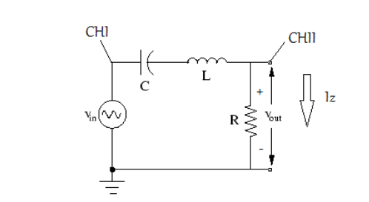

FIGURE 1:
a-)
f= 100 Hz (YT format)
CH1 ( $V_{in}(jw)$ : 500 mv
CH2($V_{out}(jw)$: 500 mv
Sec/div: 500 µs
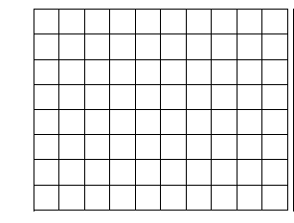
b-)
f=100 Hz (XY format)
CH1 ( $V_{in}(jw)$ : 500 mv
CH2($V_{out}(jw)$: 500 mv
Sec/div: 500 µs

FIGURE 2:
a-)
f=resonance frequency (XY FORMAT)
CH1 ( $V_{in}(jw)$ : 2 V
CH2($V_{out}(jw)$: 1 V
Sec/div: 2.50 ms
b-)
f=resonance frequency (YT FORMAT)
CH1 ( $V_{in}(jw)$ : 2 V
CH2($V_{out}(jw)$: 1 V
Sec/div: 2.50 ms

FIGURE 3:
a-)
f=1000 Hz (XY format)
CH1 ( $V_{in}(jw)$ : 2 V
CH2($V_{out}(jw)$: 1 V
Sec/div: 500 µs

b-)
f=1000 Hz (YT format)
CH1 ( $V_{in}(jw)$ : 2 V
CH2($V_{out}(jw)$: 1 V
Sec/div: 500 µs

