Ece 232 - Advanced Electrical Circuit Analysis Lab Manual 6
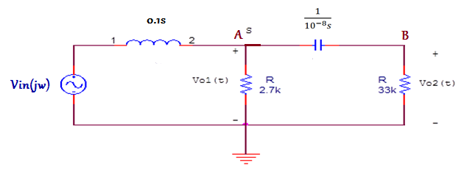

$$\frac{V_{i}-A}{0.1s}=\frac{A}{2700}+\frac{As}{{10}^{8}+33000s}$$
$$V_{i}=A(\frac{27*{10}^{9}+991*{10}^{4}s+357s^{2}}{27*{10}^{9}+891*{10}^{4}s})$$
$$\frac{A}{\frac{{10}^{8 }}{s}+33000}=\frac{B}{33000}$$
$$A=B\frac{{33s+10}^{5 }}{33s}$$
$$V_{i}=B\frac{{33s+10}^{5 }}{33s}(\frac{27*{10}^{9}+991*{10}^{4}s+357s^{2}}{27*{10}^{9}+891*{10}^{4}s})$$

$$B=V_{o_{2}}$$
$$V_{i}=V_{o_{2}}\frac{{33s+10}^{5 }}{33s}(\frac{27*{10}^{9}+991*{10}^{4}s+357s^{2}}{27*{10}^{4}({33s+10}^{5 })})$$

$$\frac{V_{o_{2}}}{V_{i}} =H_{2}\left(s\right)=\frac{33*27*{10}^{4}*s}{27*{10}^{9}+991*{10}^{4}s+357s^{2}}$$
$$H_{2}\left(jw\right)=\frac{891*{10}^{4}*jw}{27*{10}^{9}+991*{10}^{4}jw-357w^{2}}$$
Magnitude response
$$\left|H_{2}\left(jw\right)\right|=\frac{891*{10}^{4}*w}{\sqrt{{991}^{2}*{10}^{8}w^{2}+{\left(27*{10}^{9}-357w^{2}\right)}^{2}}}$$

Phase response
$$H_{2}\left(jw\right)=\frac{891*{10}^{4}*jw}{27*{10}^{9}+991*{10}^{4}jw-357w^{2}}$$
$$by multiplying by conjugate$$
$$Arg\left(H_{2}\left(jw\right)\right)=\tan^{-1}{\frac{27*{10}^{9}w-357w^{3}}{991*{10}^{4}*w^{2}}}=\tan^{-1}{\frac{27*{10}^{9}-357w^{2}}{991*{10}^{4}*w}}$$
For resonant angular frequency the imaginary part of the response must be zero
$$H_{2}\left(jw\right)=\frac{891*{10}^{4}*\left[\left(27*{10}^{9}w-357w^{3}\right)j+991{*10}^{4}w^{2}\right]}{{\left(27*{10}^{9}-357w^{2}\right)}^{2}+{\left(991*{10}^{4}w\right)}^{2}}$$
$$27*{10}^{9}w-357w^{3}=0$$
$w=0$ or
$$w^{2}=\frac{{27*10}^{9}}{357}$$
$$w=\sqrt{\frac{{27*10}^{9}}{357}}=0.8697*{10}^{4}=8697\frac{rad}{sec}=1385Hertz$$
The magnitude at the resonant angular frequency
$$H_{2}\left(jw\right)=\frac{891*{10}^{4}*\left[\left(\frac{{27*10}^{9}}{357}\right)*991{*10}^{4}\right]}{\left(\frac{{27*10}^{9}}{357}\right)*{\left(991*{10}^{4}\right)}^{2}}=\frac{891}{991}=0.899$$

When does $\left|H_{2}\left(jw\right)\right|$ reaches its maximum value
$$\frac{d}{dw}\left|H_{2}\left(jw\right)\right|=\frac{891*{10}^{4}*\left[-2*127449w^{4}+2*729{*10}^{18}\right]}{2(127449w^{4}+789301*{10}^{8}w^{2}+729*{10}^{16})}=0$$
$$w^{4}=2*\frac{729{*10}^{18}}{2*127449}$$
$$w^{2}=\frac{{27*10}^{9}}{357}$$
$$w≅\frac{8697rad}{sec}=1385Hertz$$
These results indicates that the max value for $\left|H_{2}\left(jw\right)\right|$, obtained when the circuit is operating in the resonant frequency. $arg{(\left|H_{2}\left(jw\right)\right|)}_{max}=w_{resonant-frequency}$
$\left|H_{2}\left(jw\right)\right|=1$This value is not possible since ${(\left|H_{2}\left(jw\right)\right|)}_{max}=0.89$
To find the corner frequencies (half-power frequencies) find the frequencies where phase$=∓{45}^{o}$
First corner frequency
$$\tan^{-1}{\frac{27*{10}^{9}-357w^{2}}{991*{10}^{4}*w}}={45}^{o}$$
$$1=\frac{27*{10}^{9}-357w^{2}}{991*{10}^{4}*w}$$
$$0=357w^{2}+991*{10}^{4}*w-27*{10}^{9}$$
$$w_{1,2}=\frac{-991*{10}^{4}∓\sqrt{{\left(991*{10}^{4}\right)}^{2}+4*357*27*{10}^{9}}}{2*357}=0.2499*{10}^{4}=\frac{2499rad}{sec}=398Hertz$$
Second corner frequency
$$\tan^{-1}{\frac{27*{10}^{9}-357w^{2}}{991*{10}^{4}*w}}={-45}^{o}$$
$$-1=\frac{27*{10}^{9}-357w^{2}}{991*{10}^{4}*w}$$
$$0=357w^{2}-991*{10}^{4}*w-27*{10}^{9}$$
$$w_{1,2}=\frac{991*{10}^{4}∓\sqrt{{\left(991*{10}^{4}\right)}^{2}+4*357*27*{10}^{9}}}{2*357}=30259red/sec=4818Hertz$$
$\left|H_{2}\left(jw\right)\right|$ at corner frequencies
$$H_{2}\left(jw\right)=\frac{891*{10}^{4}*991{*10}^{4}w^{2}\left[\frac{\left(27*{10}^{9}w-357w^{3}\right)}{991{*10}^{4}w^{2}}j+1\right]}{{\left(991*{10}^{4}w\right)}^{2}{\left(1+\frac{27*{10}^{9}-357w^{2}}{991*{10}^{4}w}\right)}^{2}}$$

$$at w_{c1} \frac{27*{10}^{9}-357w^{2}}{991*{10}^{4}*w}=1 at w_{c2} \frac{27*{10}^{9}-357w^{2}}{991*{10}^{4}*w}=-1$$
$$H_{2}\left(w_{c1}\right)=\frac{891}{991}*\frac{1+j}{1+1^{2}}=\frac{891}{991}*\frac{1+j}{2} H_{2}\left(w_{c2}\right)=\frac{891}{991}*\frac{1-j}{1+1^{2}}=\frac{891}{991}*\frac{1-j}{2}$$
$$\left|H_{2}\left(w_{c1}\right)\right|=\frac{891}{991}*\frac{1}{\sqrt{2}}=\frac{0.899}{\sqrt{2}} \left|H_{2}\left(w_{c2}\right)\right|=\frac{891}{991}*\frac{1}{\sqrt{2}}=\frac{0.899}{\sqrt{2}}$$
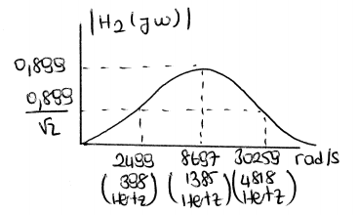
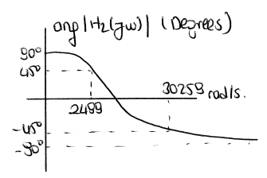

$$∆w={w_{c2}-w}_{c1}=27760rad/sec$$
$$\left|w_{1}-w_{2}\right|=bandwidth$$
$$H\left(s\right)*H_{1}\left(s\right)=\frac{\left(33*{10}^{3}\right)}{\left({33s*10}^{3}+\frac{{10}^{8}}{s}\right)}*\frac{2700}{2700+0.1s}$$
$$H\left(s\right)*H_{1}\left(s\right)=\frac{\left(5*33*27*{10}^{5}\right)}{\left({33s+10}^{5}\right){10}^{3}(27000+s){10}^{-1}}≅\frac{249575}{\left(s+24696\right)(s+3063)}$$
We can see that the gain the zeros and poles of two systems are so close to each other as seen ………….. allows.

2- L=0.1H, $w_{o}=10krad/sec$, $V_{i}(t)=Vsin(wt)$
$$f_{o}=1592Hertz$$
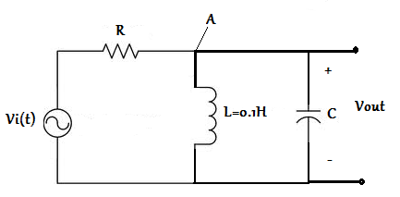

$$\frac{V_{i}-A}{R}=\frac{A}{jw*0.1}+\frac{A}{\frac{1}{jwC}}$$
$$\frac{A}{V_{i}}=\frac{w}{w+j(w^{2}CR-10R)}=\frac{V_{o}(jw)}{V_{i}(jw)}=H(jw)$$

- $R=3.3kΩ$

To find the resonant angular frequency

$$w^{2}CR-10R=0$$
$$C=\frac{10}{{w_{o}}^{2}}=\frac{10}{{10}^{8}}=0.1μF$$
Value of C independent of R.

To find half-power frequency

$$\frac{w_{c}^{2}}{w_{c}^{2}+{(w_{c}^{2}CR-10R)}^{2}}=\frac{1}{2}$$
$$w_{c}^{4}-\left(2+\frac{1}{{3.3}^{2}}\right){10}^{8}w_{c}^{2}+{10}^{16}=0$$
$$w_{c1}=8599rad/\sec{ f_{1}=}1369Hertz$$
$$w_{c2}=11625rad/\sec{ f_{2}=1851Hertz}$$
$$∆w={w_{c2}-w}_{c1}=3029rad/sec$$
$$Q=\frac{w_{c}^{ }}{∆w}=\frac{10000}{3029}=3.3$$
- $R=10kΩ$, L=0.1H, $w_{o}=10krad/sec$, $f_{o}=1592Hertz$

$$C=0.1μF$$
Since it is independent of R.

To find half-power frequency

$$\frac{w_{c}^{2}}{w_{c}^{2}+{(w_{c}^{2}CR-10R)}^{2}}=\frac{1}{2}$$

$$w_{c}^{4}C^{2}R^{2}-{20w}_{c}^{2}CR^{2}-w_{c}^{2}+100R^{2}=0$$
$$w_{c1}=10510rad/\sec{ f_{1}=}1673Hertz$$
$$w_{c2}=9517rad/\sec{ f_{2}=1514Hertz}$$
$$∆w={w_{c2}-w}_{c1}=998rad/sec$$
$$Q=\frac{w_{c}^{ }}{∆w}=\frac{10000}{998}≅10$$

$$H\left(jw\right)=\frac{w}{w+j(w^{2}{10}^{-7}{10}^{4}-10*{10}^{4})}$$
$$\left|H\left(jw\right)\right|=\frac{w}{\sqrt{w^{2}+{(w^{2}{10}^{-3}-{10}^{5})}^{2}}}$$

$$arg\left(H\left(jw\right)\right)=\tan^{-1}{(\frac{-w^{2}{10}^{-3}-{10}^{5}}{w})}$$

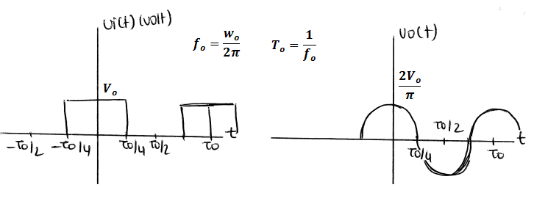

$$V_{i}\left(t\right)=V_{o}\left[\frac{1}{2}+\frac{2}{π}\cos\left(w_{o}t\right)-\frac{2}{3π}\cos\left(3w_{o}t\right)+\frac{2}{5π}\cos\left(5w_{o}t\right)-…\right]$$
Since the filter is a band-pass filter with critical frequency $w_{o}$ only the components of $V_{i}(t)$ with frequency $w_{o}$ passes. DC components and other frequencies dies out at the output.
4. In Preliminary work part 1, the filter is a high-pass filter.
In Preliminary work part 2a, the filter is a low-pass filter.
In Preliminary work part 2b, the filter is a band-pass filter.

