Ece 232 - Advanced Electrical Circuit Analysis Lab
Frequency response (phase, magnitude characteristics
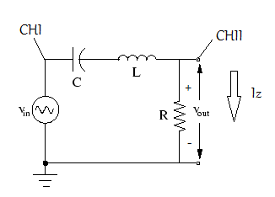
$$L=0.1 H, C=10μF, R=1kΩ$$
$$V_{in}\left(t\right)=1\sin{2πft}$$
$$f=2500Hz$$

CHI $The voltage observed over the impedance Z, where Z=sL+\frac{1}{SC}+R$
[Since all components are in series]
CHII $V_{out}=RI_{Z} I_{Z}(in mA)$ [$I_{Z} is the total current over the impedance Z$]
- $V_{Z} is shown by CHI in Volts.$
- $I_{Z} or V_{out} is shown by CHII in mAmpers or Volt.$
CHI vs. CHII shows the voltage-current relation for Z.
$$H\left(jw\right)=\frac{V_{out}\left(jw\right)}{V_{in }(jw)}=\frac{1000jw}{{(10}^{5}-0.1w^{2})+\left(1000jw\right)}$$
$\left|H(jw)\right|=\frac{1000w}{\sqrt{{\left({10}^{5}-0.1w^{2}\right)}^{2}+{\left(1000w\right)}^{2}}}$ (magnitude characteristics)
To obtain resonant frequency equate real part of the denominator of H(jw) to 0.
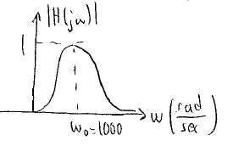
Hence ${10}^{5}-0.1w^{2}=0$ $w_{o}=1000rad/sec$ {resonant freq.}

- If f=2500Hz and w=15700rad/sec
$$∠H\left(jw\right)=∠V_{out}\left(jw\right)-∠V_{in }\left(jw\right)=90-\tan^{-1}{\frac{1000w}{{(10}^{5}-0.1w^{2})}} (phase characteristics)$$
$w=0$ $∠H\left(jw\right)=90$
$w=w_{0}=1000rad/sec$ $∠H\left(jw\right)=0$
$w=15700rad/sec$ $90-\tan^{-1}{\frac{1000w}{{(10}^{5}-0.1*{(15700)}^{2})}}= 90-\tan^{-1}{\frac{157}{-245.49}}$

$$∠H\left(jw\right)=90-148=-58$$
$$∠H\left(jw\right)=∠V_{out}\left(jw\right)-∠V_{in }\left(jw\right)=∠I_{Z}-∠V_{Z}=-58$$
$V_{in }\left(V_{Z}\right) is leading V_{out} \left(I_{Z}\right) by {58}^{0}.$The impedance is inductive.
$$T=\frac{1}{f}=\frac{1}{2500Hz}=0.4msec$$
d : phase distance
$$θ:phase difference=\frac{d}{T}*360$$
$$∠H\left(jw\right)=-∠Z\left(jw\right)=-58$$
$∠Z\left(jw\right)=58$ {$V_{Z}is leading I_{Z}, I_{Z} is lagging V_{Z}$}
$\left|∠Z(jw)\right|=\frac{A}{B} when w=15700rad/sec$

- Y-T mode [CHI and CHII are drawn w.r.t time t]

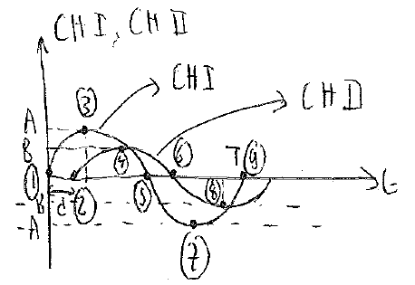

- Corresponding X-Y mode

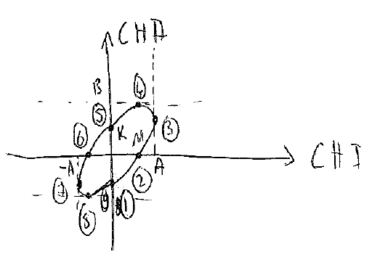
$$\left|∠Z(jw)\right|=\frac{A}{B}$$
$$∠Z\left(jw\right)=arcsin\frac{K}{B}=\arcsin{\frac{M}{A}}$$

Although we can find the phase by $∠Z\left(jw\right)=arcsin\frac{K}{B}=\arcsin{\frac{M}{A}}$ , we cannot identify precisely whether the phase is lagging or leading (we cannot say CHI is leading or lagging)

